

**Amrita School of Computing**

**Coimbatore- 641 112, Tamil Nadu, India**

**Human Activity Recognition Using Smartphones Sensors**

**By**

**Saminathan R- (CB.SC.P2AIE23003)**

**Saikrishna Rajanidi- (CB.SC.P2AIE23011)**

**Sebin Beebi Philip- (CB.SC.P2AIE23020)**

**Supervised by:**

**Dr. SenthilKumar T**

**November-2023**

**MACHINE LEARNING PROJECT REPORT**

|  |  |  |  |
| --- | --- | --- | --- |
| **RollNo** | **Name** | **Official Email id** | **Contribution** |
| CB.SC.P2AIE23003 | Saminathan R | cb.sc.p2aie23003@cb.students.amrita.edu | Building Logistic regression ,GRU, Random Forest model and analyze it with metrics, confusion matrix and print accuracy and documentation works. |
| CB.SC.P2AIE23011 | Saikrishna Rajanidi | c.sc.p2aie23011@cb.students.amrita.edu | Dataset Analysis, Data Preprocessing – label encoding, balancing dataset using SMOTE, Handling Noise in the data – adding, removing gaussian noise, random spikes, Code refactoring.  Training LSTM model, hyperparameter tuning and analysing the model.  Training MLP model, and analysing the model’s performance. |
| CB.SC.P2AIE23020 | Sebin Beebi Philip | cb.sc.p2aie23020@cb.students.amrita.edu | Building KNN model and SVM with K-Means ,Naïve Bayes Classifier and analyze it with metrics, confusion matrix and print accuracy and documentation works |

**GitHub URL of the project page:**

<https://github.com/sebin253/Group_14_ML_Mini_Project.git>

**Kaggle URL of the dataset page:**

<https://www.kaggle.com/datasets/uciml/human-activity-recognition-with-smartphones>

**SECTION-1**

**1.1 Application Name:** Human Activity Recognition Using Smartphones Sensors

**1.2 Description:** Smart Human Activity Tracker pioneers a breakthrough in human activity recognition, addressing the challenging time series classification task with unparalleled precision. Predicting the movement of an individual based on sensor data is no longer reserved for experts in signal processing. This application eliminates the need for deep domain expertise by seamlessly integrating advanced machine learning and deep learning techniques, transforming raw sensor data into actionable insights for a sophisticated machine learning model.

**1.3 Analytical Questions: -**

**1. Why are smartphone sensors chosen for activity recognition?**

* **Built-in Sensor Suite:** Modern smartphones come equipped with a variety of built-in sensors, including accelerometers, gyroscopes, magnetometers, GPS, and sometimes even barometers. These sensors can capture a wide range of information related to users' movements and environmental conditions.
* **Continuous Monitoring:** Smartphones can provide continuous monitoring of user activities throughout the day. The portability and constant presence of smartphones allow for the collection of long-term and real-world activity data, providing a comprehensive view of users' behaviour.
* **Multimodal Sensing:** Smartphones often integrate multiple sensors, enabling multimodal sensing. Combining data from accelerometers, gyroscopes, and magnetometers, for example, allows for a more comprehensive understanding of complex activities involving both motion and orientation.
* **User Comfort and Convenience:** Users commonly carry smartphones with them throughout the day, making them a convenient choice for activity recognition. This minimizes the need for users to wear additional devices or accessories, increasing user comfort and adherence to the system.
* **Cost-Effectiveness:** Utilizing smartphone sensors eliminates the need for external, dedicated hardware, which can be costly to develop, manufacture, and distribute. Leveraging built-in sensors makes activity recognition more cost-effective and accessible.
* **Widespread Availability:** Smartphones are ubiquitous and widely used, making them readily available to a large portion of the population. Leveraging smartphones for activity recognition allows for scalable and widespread deployment of such systems.

**2. Why is Machine learning selected as the primary technique for analysis?**

* **Pattern Recognition in Large Datasets:** Machine learning is well-suited for analyzing large and high-dimensional datasets. It can effectively identify patterns, trends, and relationships within the data that might be challenging for humans to discern.
* **Complex and Nonlinear Relationships:** Machine learning algorithms can capture complex and nonlinear relationships between input features and output predictions. This flexibility allows for modeling intricate patterns that may not be easily expressed through traditional rule-based systems.
* **Handling Noisy and Incomplete Data:** Real-world datasets are often noisy, incomplete, or contain outliers. Machine learning algorithms can handle such imperfections and still provide meaningful insights or predictions, making them robust in the face of data uncertainties.
* **Scalability:** Machine learning algorithms can scale to handle large and diverse datasets, making them suitable for applications in various domains, from healthcare to finance to image recognition.
* **Efficiency in Feature Extraction:** Machine learning algorithms can automatically extract relevant features from raw data, eliminating the need for manual feature engineering. This is particularly advantageous when dealing with high-dimensional datasets.

**3. What advantages do they offer over other methods?**

Machine learning offers several advantages over traditional methods in various domains, contributing to its widespread adoption and success. Here are some key advantages of machine learning compared to other methods:

* **Automated Pattern Recognition:** Machine learning algorithms automatically identify patterns and relationships in data without explicit programming, making it well-suited for complex tasks where patterns may be intricate or difficult to articulate manually.
* **Handling Large and Complex Datasets:** Machine learning can efficiently process and analyze large volumes of data, including high-dimensional datasets, which might be impractical or challenging for traditional methods.
* **Feature Extraction and Representation Learning:** Machine learning algorithms can automatically extract relevant features from raw data, eliminating the need for manual feature engineering in some cases.
* **Efficiency and Speed:** Machine learning algorithms can process and analyze data at a faster rate than traditional methods, leading to more efficient and timely decision-making.

**4. What specific activities are targeted for recognition in the dataset?**

The User activities targeted in our dataset are:

* STANDING
* SITTING
* LAYING
* WALKING
* WALKING_DOWNSTAIRS
* WALKING_UPSTAIRS

**5. How does focusing on these activities address specific user needs or industry requirements?**

* **Health and Wellness Monitoring:**

**User Needs:** Individuals and healthcare professionals may be interested in monitoring physical activities to assess overall health and well-being.

**Industry Requirements:** Wearable devices and smartphone applications can leverage HAR to provide insights into users' activity levels, promoting physical fitness and health monitoring.

* **Fitness Tracking:**

**User Needs:** Fitness enthusiasts and individuals engaged in specific training programs seek accurate tracking of activities for performance evaluation.

**Industry Requirements:** Fitness tracking apps and devices use HAR to monitor activities like walking, running, or climbing stairs, helping users achieve their fitness goals.

* **Fall Detection and Elderly Care:**

**User Needs:** Elderly individuals or those with mobility issues may require assistance in the case of falls or difficulty in performing certain activities.

**Industry Requirements:** HAR can be integrated into smart home systems or wearables to detect falls or changes in activity patterns, triggering alerts or providing support as needed.

* **Activity-based User Interfaces:**

**User Needs:** Efficient and context-aware user interfaces that adapt based on users' activities can enhance user experience.

**Industry Requirements:** HAR can contribute to the development of adaptive user interfaces, adjusting the presentation of information or controls based on the user's current activity.

* **Workplace Ergonomics:**

**User Needs:** Employees and employers may be interested in promoting better workplace ergonomics and preventing sedentary behaviour.

**Industry Requirements:** HAR can be employed to monitor sitting, standing, or lying activities, helping individuals and organizations make informed decisions about workstation setups and breaks.

* **Security and Access Control:**

**User Needs:** Security-conscious environments may require additional authentication measures based on users' activities.

**Industry Requirements:** HAR can contribute to biometric systems by incorporating activity recognition for access control, ensuring that access is granted based on recognized patterns of movement.

* **Navigation and Location-based Services:**

**User Needs:** Users may want navigation systems that adapt to different modes of transportation or walking.

**Industry Requirements:** HAR can enhance location-based services by recognizing activities such as walking, walking upstairs, or walking downstairs, providing more accurate navigation instructions.

* **Sports Performance Analysis:**

**User Needs:** Athletes and sports professionals may seek detailed insights into their performance during different activities.

**Industry Requirements:** HAR can be integrated into sports analytics platforms to provide coaches and athletes with data on specific activities, aiding in performance optimization.

**6. How are these features engineered to enhance model performance?**

An extensive feature engineering was done to construct time-domain, frequency-domain signals obtained from the accelerometer and gyroscope of smartphone and statistical features by the appropriate domain experts.

**7. How was data Preprocessing done?**

The data was preprocessed already by the authors of dataset and then we added the label encoder to convert the string class labels to integer class labels and we introduced noise by applying gaussian noise and random spikes to the data, and then they were removed using Gaussian filter and median filter, SMOTE (Synthetic Minority Oversampling Technique) algorithm was used to balance the dataset.

**1.4 Provide a set of questions for prediction**

1. **What is the accuracy, precision, recall, f1 score of the best model?**

Multinomial Logistic Regression is the best performing model with accuracy of 94.02%, precision of 0.9409, recall of 0.9402 and f1 score of 0.9403.

1. **How are the models optimized to make the best prediction?**

An Extensive hyperparameter tuning was done to select the best possible combination of hyperparameters and design the best performing model and each model was analysed thoroughly in order to arrive at the best solution.

**1.5 Technologies**

|  |  |
| --- | --- |
| **Editor** | **Jupyter Notebook** |
| **Language** | **Python** |

**1.6 Why Human Activity Recognition (HAR) is needed?**

* **Enhancing Health and Fitness Monitoring:** The application of HAR using smartphone sensors is crucial for health and fitness monitoring. It allows individuals to track and analyze their physical activities, promoting a healthier lifestyle by providing insights into exercise routines, sedentary behaviors, and overall movement patterns.
* **Personalized User Experience:** HAR contributes to the development of personalized user experiences in applications and services. By understanding individual activity patterns, applications can tailor recommendations, alerts, or notifications to better suit the user's specific needs and goals.
* **Improving Accessibility and User Assistance:** This technology is essential for creating more accessible and user-friendly interfaces. HAR can be integrated into applications that provide assistance to users with mobility challenges, offering a more inclusive experience by adapting to their physical activities and movements.
* **Efficient Resource Utilization:** HAR using smartphone sensors optimizes resource utilization. By relying on the built-in sensors of ubiquitous devices like smartphones, it minimizes the need for additional hardware, making it a cost-effective and widely applicable solution.

**1.7 List of similar Applications:**

|  |  |
| --- | --- |
| **Application Name** | **URL** |
| Health and Fitness Monitoring | https://www.deepseadev.com/en/blog/fitness-monitoring-benefits/ |
| Sports performance analysis | https://www.v7labs.com/blog/human-activity-recognition#applications-and-uses-of-human-activity-recognition |
| Self-driving cars | https://www.v7labs.com/blog/human-activity-recognition#applications-and-uses-of-human-activity-recognition |
| Smart surveillance | https://www.v7labs.com/blog/human-activity-recognition#applications-and-uses-of-human-activity-recognition |

**1.8 What is unique in your project?**

* We have added gaussian and random spikes noise to better simulate the real-world situations.
* We have done extensive hyper parameter tuning in each model to pick the best performing models.
* We have done comprehensive analysis on each model to understand the micro level working of each model.
* We have tried a wide variety of models from Machine Learning ( Nearest neighbours search , linear models , probabilistic models , ensemble models) to Deep Learning (Simple MLP , Sequential model)

**SECTION – 2**

**2.1 Conference Paper Details:**

|  |  |  |  |
| --- | --- | --- | --- |
| **S. NO** | **Paper Name** | **Conference Name** | **Citation** |
| 1 | Searching Efficient Models for Human Activity Recognition | Association for Computing Machinery | Shamisa Kaspour, Nikhil Raj, Alankrit Mishra, Abdulsalam Yassine, and Thiago Eustaquio Alves De Oliveira. 2022. Searching Efficient Models for Human Activity Recognition. In Proceedings of the 2021 6th International Conference on Biomedical Imaging, Signal Processing (ICBSP '21). Association for Computing Machinery, New York, NY, USA, 40–45. https://doi.org/10.1145/3502803.3502809 |
| 2 | BCL: A Branched CNN-LSTM Architecture for Human Activity Recognition Using Smartphone  Sensors | International Conference on Next-Generation Computing, IoT and Machine Learning (NCIM) | S. Al Farshi Oman, M. N. Jamil and S. M. T. U. Raju, "BCL: A Branched CNN-LSTM Architecture for Human Activity Recognition Using Smartphone Sensors," 2023 International Conference on Next-Generation Computing, IoT and Machine Learning (NCIM), Gazipur, Bangladesh, 2023, pp. 1-5, doi: 10.1109/NCIM59001.2023.10212972. |
| 3 | Physique-Based Human Activity Recognition Using  Deep Learning Approaches and Smartphone Sensors | International Conference on Digital Arts, Media and Technology (DAMT) | S. Pravesjit, P. Jantawong, A. Jitpattanakul and S. Mekruksavanich, "Physique- Based Human Activity Recognition Using Deep Learning Approaches and Smartphone Sensors," 2023 Joint International Conference on Digital Arts, Media and Technology with ECTI Northern Section Conference on Electrical, Electronics, Computer and Telecommunications Engineering (ECTI DAMT & NCON), Phuket, Thailand, 2023, pp. 479-482, doi: 10.1109/ECTIDAMTNCON57770.2023.10139396. |
| 4 | Human Action Recognition in Still Images | Computer Vision and Image Processing. CVIP | Palak, Chaudhary, S. (2022). Human Action Recognition in Still Images. In: Raman, B., Murala, S., Chowdhury, A., Dhall, A., Goyal, P. (eds) Computer Vision and Image Processing. CVIP 2021. Communications in Computer and Information Science, vol 1568. Springer, Cham. https://doi.org/10.1007/978-3-031-11349-9_42 |
| 5 | Miss-placement Prediction of Multiple On-body Devices for Human Activity Recognition | Association for Computing Machinery | Robin Dönnebrink, Fernando Moya Rueda, Rene Grzeszick, and Maximilian Stach. 2023. Miss-placement Prediction of Multiple On-body Devices for Human Activity Recognition. In Proceedings of the 8th international Workshop on Sensor-Based Activity Recognition and Artificial Intelligence (iWOAR '23). Association for Computing Machinery, New York, NY, USA, Article 19, 1–8. https://doi.org/10.1145/3615834.3615838 |
| 6 | A Study on Hyperparameters Configurations for an Efficient Human Activity Recognition System | Association for Computing Machinery | Paulo J.S. Ferreira, Joao Mendes Moreira, and Joao M.P. Cardoso. 2023. A Study on Hyperparameters Configurations for an Efficient Human Activity Recognition System. In Proceedings of the 8th international Workshop on Sensor-Based Activity Recognition and Artificial Intelligence (iWOAR '23). Association for Computing Machinery, New York, NY, USA, Article 11, 1–6. https://doi.org/10.1145/3615834.3615851 |
| 7 | Exploring the Benefits of Time Series Data Augmentation for Wearable Human Activity Recognition. | Association for Computing Machinery | Md Abid Hasan, Frederic Li, Artur Piet, Philip Gouverneur, Muhammad Tausif Irshad, and Marcin Grzegorzek. 2023. Exploring the Benefits of Time Series Data Augmentation for Wearable Human Activity Recognition. In Proceedings of the 8th international Workshop on Sensor-Based Activity Recognition and Artificial Intelligence (iWOAR '23). Association for Computing Machinery, New York, NY, USA, Article 20, 1–7. https://doi.org/10.1145/3615834.3615842 |
| 8 | Reinforcement Learning Based Online Active Learning for Human Activity Recognition | Association for Computing Machinery | Yulai Cui, Shruthi Kashinath Hiremath, and Thomas Ploetz. 2022. Reinforcement Learning Based Online Active Learning for Human Activity Recognition. In Proceedings of the 2022 ACM International Symposium on Wearable Computers (ISWC '22). Association for Computing Machinery, New York, NY, USA, 23–27. https://doi.org/10.1145/3544794.3558457 |
| 9 | Human Activity Recognition using Time Series Feature Extraction and Active Learning. | Association for Computing Machinery | Vangjel Kazllarof and Sotiris Kotsiantis. 2022. Human Activity Recognition using Time Series Feature Extraction and Active Learning. In Proceedings of the 12th Hellenic Conference on Artificial Intelligence (SETN '22). Association for Computing Machinery, New York, NY, USA, Article 46, 1–4. https://doi.org/10.1145/3549737.3549787 |
| 10 | Human Activity Recognition Based on Convolutional Neural Network via Smart-phone Sensors | Association for Computing Machinery | Zesheng Chen, Min Zhou, Lichun Feng, and Bingnan Li. 2022. Human Activity Recognition Based on Convolutional Neural Network via Smart-phone Sensors. In Proceedings of the 2022 5th International Conference on Signal Processing and Machine Learning (SPML '22). Association for Computing Machinery, New York, NY, USA, 140–145. https://doi.org/10.1145/3556384.3556406 |

**2.2 Journal Paper Details:**

|  |  |  |  |
| --- | --- | --- | --- |
| **S. No** | **Paper Name** | **Journal Name** | **Citation** |
| 1 | Human Activity Recognition Using 2-D LiDAR and Deep Learning Technology | IEEE | Q. -Y. Yao, P. -L. Chen and T. -S. Chen, "Human Activity Recognition Using 2-D LiDAR and Deep Learning Technology," in IEEE Sensors Letters, vol. 7, no. 10, pp. 1-4, Oct. 2023, Art no. 5503204, doi: 10.1109/LSENS.2023.3316882. |
| 2 | Enhanced Prediction Model for Human Activity Using an End-to-End Approach | IEEE | S. Park, H. O. Lee, Y. M. Hwang, S. -K. Ko and B. -T. Lee, "Enhanced Prediction Model for Human Activity Using an End-to-End Approach," in IEEE Internet of Things Journal, vol. 10, no. 7, pp. 6031-6041, 1 April1, 2023, doi: 10.1109/JIOT.2022.3223674. |
| 3 | Exploratory Analysis of Smartphone Sensor Data for Human Activity Recognition | IEEE | S. M. M. Islam and K. H. Talukder, "Exploratory Analysis of Smartphone Sensor Data for Human Activity Recognition," in IEEE Access, vol. 11, pp. 99481-99498, 2023, doi: 10.1109/ACCESS.2023.3314651. |
| 4 | Smartphone Sensor-Based Human Activity Recognition Robust to Different Sampling Rates | IEEE | T. Hasegawa, "Smartphone Sensor-Based Human Activity Recognition Robust to Different Sampling Rates," in IEEE Sensors Journal, vol. 21, no. 5, pp. 6930-6941, 1 March1, 2021, doi: 10.1109/JSEN.2020.3038281. |
| 5 | An Adaptive Batch Size-Based-CNN-LSTM  Framework for Human Activity Recognition  in Uncontrolled Environment | IEEE | N. A. Choudhury and B. Soni, "An Adaptive Batch Size-Based-CNN-LSTM Framework for Human Activity Recognition in Uncontrolled Environment," in IEEE Transactions on Industrial Informatics, vol. 19, no. 10, pp. 10379-10387, Oct. 2023, doi: 10.1109/TII.2022.3229522. |
| 6 | Enhanced Complex Human Activity Recognition System: A Proficient Deep  Learning Framework Exploiting Physiological Sensors and Feature Learning | IEEE | N. A. Choudhury and B. Soni, "Enhanced Complex Human Activity Recognition System: A Proficient Deep Learning Framework Exploiting Physiological Sensors and Feature Learning," in IEEE Sensors Letters, vol. 7, no. 11, pp. 1-4, Nov. 2023, Art no. 6008104, doi: 10.1109/LSENS.2023.3326126. |
| 7 | Exploratory Analysis of Smartphone Sensor Data  for Human Activity Recognition | IEEE | S. M. M. Islam and K. H. Talukder, "Exploratory Analysis of Smartphone Sensor Data for Human Activity Recognition," in IEEE Access, vol. 11, pp. 99481-99498, 2023, doi: 10.1109/ACCESS.2023.3314651. |
| 8 | Human Activity Recognition Using Smartphones  With Wi-Fi Signals | IEEE | G. Lin et al., "Human Activity Recognition Using Smartphones With WiFi Signals," in IEEE Transactions on Human-Machine Systems, vol. 53, no. 1, pp. 142-153, Feb. 2023, doi: 10.1109/THMS.2022.3188726. |
| 9 | MarNASNets: Toward CNN Model Architectures  Specific to Sensor-Based Human  Activity Recognition | IEEE | S. Kobayashi, T. Hasegawa, T. Miyoshi and M. Koshino, "MarNASNets: Toward CNN Model Architectures Specific to Sensor-Based Human Activity Recognition," in IEEE Sensors Journal, vol. 23, no. 16, pp. 18708-18717, 15 Aug.15, 2023, doi: 10.1109/JSEN.2023.3292380. |
| 10 | Multi-Sensor-Based Action Monitoring and  Recognition via Hybrid Descriptors and  Logistic Regression | IEEE | S. Hafeez, S. S. Alotaibi, A. Alazeb, N. A. Mudawi and W. Kim, "Multi-Sensor-Based Action Monitoring and Recognition via Hybrid Descriptors and Logistic Regression," in IEEE Access, vol. 11, pp. 48145-48157, 2023, doi: 10.1109/ACCESS.2023.3275733. |

# **SECTION-3**

**3.Dataset Description**

# Description: The UCI Human Activity Recognition Dataset is a popular benchmark dataset used for developing and evaluating machine learning models for human activity recognition .It contain data collected from accelerometers and gyroscope of a smartphone worn on the waist by 30 different subject as they perform six different activities .The dataset was collected to help in identifying the activities a person is engaged in based on sensor data .The six activities are:

# Walking

# Walking Upstairs

# Walking Downstairs

# Sitting

# Standing

# Laying

**Dataset Details:**

* Number of Instances:10,929 instances
* Number of Attributes:561 features
* Data Source: Data was collected using the embedded accelerometer and gyroscope sensor in a smartphone
* Data Collection Duration: Data was collected over a period of several seconds while subjects performed various activity.
* Data Format: The data is stored in both training and testing sets.
* Data Preprocessing: The dataset has been preprocessed, and the sensor signals have been processed to obtain feature vectors.
* Features: The features are a combination of time-domain and frequency-domain signals obtained from the accelerometer and gyroscope data.

**Citation:**

Davide Anguita, Alessandro Ghio, Luca Oneto, Xavier Parra and Jorge L. Reyes-Ortiz. A Public Domain Dataset for Human Activity Recognition Using Smartphones. 21st European Symposium on Artificial Neural Networks, Computational Intelligence and Machine Learning, ESANN 2013. Bruges, Belgium 24-26 April 2013.

**3.1 Data Preprocessing**

In our human activity recognition project using the HAR UCI dataset, we implemented a comprehensive Preprocessing pipeline to enhance the quality of the input data for model training. Initially, we addressed missing values by either imputing them based on the mean or forward-filling. To ensure uniformity, we standardized the feature values, centring them around zero with unit variance. Additionally, we applied a sliding window technique to segment the time series data into smaller, overlapping windows, allowing the model to capture temporal dependencies effectively. To further augment the dataset, we incorporated data augmentation techniques such as random noise addition and jittering. Finally, we encoded the categorical activity labels using one-hot encoding for compatibility with machine learning algorithms. This Preprocessing methodology aimed to improve model generalization and robustness by mitigating noise, handling missing data, and facilitating effective learning from the temporal patterns inherent in the human activity data.

These are the signals that we got so far.

* tBodyAcc-XYZ
* tGravityAcc-XYZ
* tBodyAccJerk-XYZ
* tBodyGyro-XYZ
* tBodyGyroJerk-XYZ
* tBodyAccMag
* tGravityAccMag
* tBodyAccJerkMag
* tBodyGyroMag
* tBodyGyroJerkMag
* fBodyAcc-XYZ
* fBodyAccJerk-XYZ
* fBodyGyro-XYZ
* fBodyAccMag
* fBodyAccJerkMag
* fBodyGyroMag
* fBodyGyroJerkMag

We can estimate some set of variables from the above signals. i.e.., We will estimate the following properties on each signal that we recorded so far.

For better remember : we can see above image, EXPERTS apply some filter on each window and get 1st vector, 2nd vector and……. so on. On top of these vector they computed below listed function.

* mean(): Mean value
* std() : Standard deviation
* mad(): Median absolute deviation
* max(): Largest value in array
* min(): Smallest value in array
* sma(): Signal magnitude area
* energy(): Energy measure. Sum of the squares divided by the number of values.
* iqr(): Interquartile range
* entropy(): Signal entropy
* arCoeff(): Autorregresion coefficients with Burg order equal to 4
* correlation(): correlation coefficient between two signals
* maxInds(): index of the frequency component with largest magnitude
* meanFreq(): Weighted average of the frequency components to obtain a mean frequency
* skewness(): skewness of the frequency domain signal
* kurtosis(): kurtosis of the frequency domain signal
* bandsEnergy(): Energy of a frequency interval within the 64 bins of the FFT of each window.
* angle(): Angle between to vectors.

We can obtain some other vectors by taking the average of signals in a single window sample. These are used on the angle() variable.

* gravityMean
* tBodyAccMean
* tBodyAccJerkMean
* tBodyGyroMean
* tBodyGyroJerkMean
  + 1. **Descriptive and Statistical Feature Analysis**

**train_data.head() –** It prints the first 5 rows of all the features.

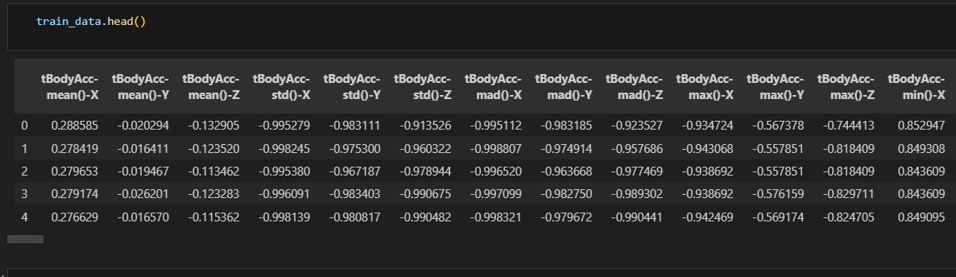

Figure 1. train_data.head()

**train_data.shape -** It gives the number of rows and columns in the dataset.

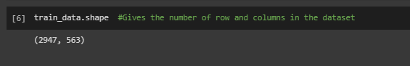

Figure 2.train_data.shape

**train_data.isnull().sum() –** It check if the sum of all the null values for each feature in the dataset.

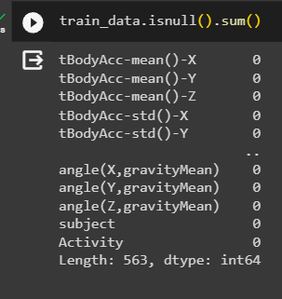

Figure 3.train_data.isnull.sum()

**train_data.describe() –** It gives the different statistical measures of the data.

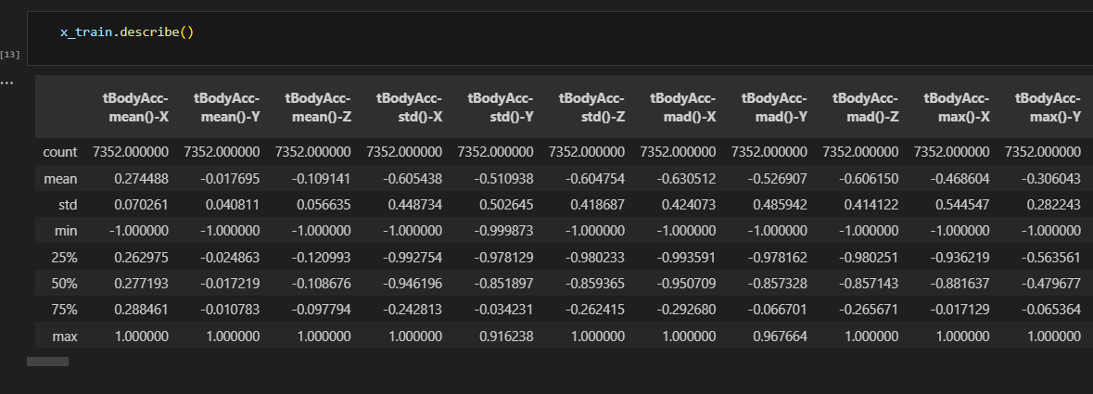

Figure 4.train_data.describe()

**train_data[‘target].value_counts() –** It prints out the number of values corresponding to one category and same for the other categories.

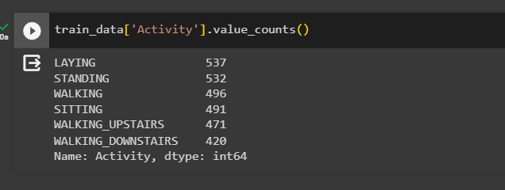

Figure 5.train_data[‘train_data’].value_counts()

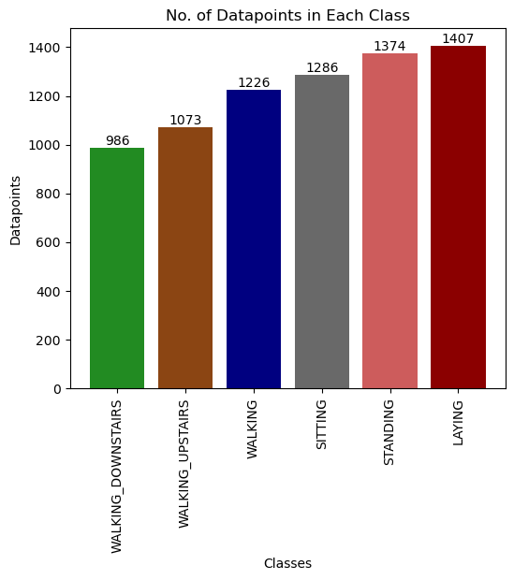

Figure 6.Data point Bar graph

After scaling all features to a standardized range of -1 to +1 and confirming the absence of missing values, the dataset exhibits a class imbalance. Furthermore, analysing the statistics of each feature reveals that after dropping the 'Subject' and 'Activity' columns, we are left with 561 usable features. These preprocessed features, now standardized and free of missing values, provide a foundation for building a model for human activity recognition, with attention warranted for addressing the class imbalance during model training.

* 1. **Balancing Dataset using SMOTE Algorithm**

In our dataset noise in data can affect model accuracy. SMOTE (Synthetic Minority Over-sampling Technique) is used for noise removal and handling imbalanced datasets. Identify minority classes (less frequent activities) in the dataset. SMOTE generates synthetic data points by interpolating between existing minority class instances. This process balances the dataset and reduces noise by smoothing irregularities. The improved dataset is then used to train a machine learning model for activity recognition. The result is a more accurate and robust model that generalizes well across various activities.

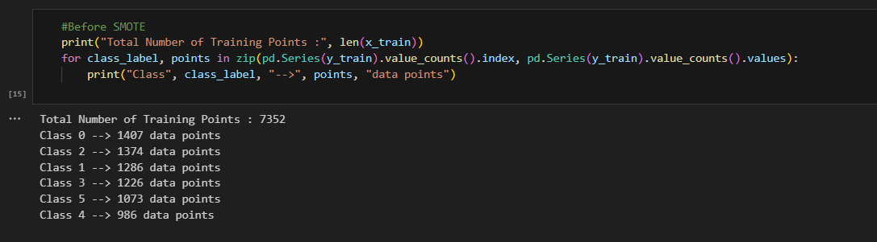

Figure 7.Before SMOTE

The total number of training points is 7352. This class imbalance can potentially impact the performance of machine learning models, especially in tasks like human activity recognition where equal representation of activities is crucial for robust model training. Applying SMOTE can help address this imbalance and improve the overall quality of the dataset.

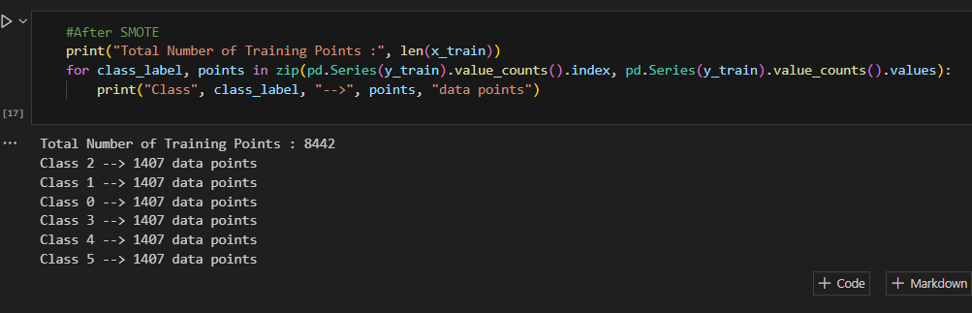

Figure 8.After SMOTE

After applying SMOTE to the dataset, the class distribution has been balanced, and the total number of training points has increased to 8442. Each class now has an equal number of 1407 of data points. This balanced distribution, achieved through SMOTE, helps address the initial class imbalance observed before applying the algorithm. It is beneficial for training machine learning models that can generalize well across different activities, contributing to improved model accuracy and performance in human activity recognition tasks.

**3.3 Adding Gaussian Noise**

Adding controlled noise serves as a regularization technique during model training. By introducing Gaussian noise to the dataset, we simulate the inherent uncertainties in sensor measurements. This helps prevent overfitting and enhances the model's ability to generalize to diverse and real-world scenarios. Additionally, the noise aids in quantifying prediction uncertainties, providing insights into the model's reliability. This approach contributes to building a more robust activity recognition model that can handle variations and uncertainties in sensor data, ultimately improving overall model performance.

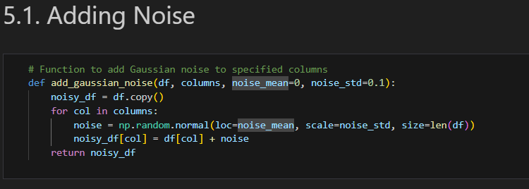

Figure 9.Adding Gaussian Noise

**Adding Random Spikes**

Addition of random spikes or outliers to selected columns within a DataFrame. It operates by creating a copy of the original DataFrame and, for each specified column, generates random spikes based on a predefined probability distribution. The magnitude and direction of the spikes are chosen from a set of predefined values. This introduces controlled variability to the data, simulating unexpected fluctuations or outliers. The resulting DataFrame, with added random spikes, can be used for testing the robustness of data processing and machine learning models to unexpected perturbations in the input data.

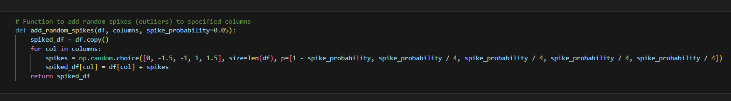

Figure 10.Adding Random Spikes

**Removing Gaussian Noise**

This function removes Gaussian noise from selected columns within a DataFrame by applying Gaussian smoothing. A copy of the original DataFrame is created, and for each specified column, the function utilizes Gaussian smoothing with a specified standard deviation (sigma) to filter out noise. The result is a cleaned DataFrame with reduced Gaussian noise in the targeted columns. This process is particularly useful in enhancing the signal-to-noise ratio and improving the quality of data for downstream analysis or modelling tasks

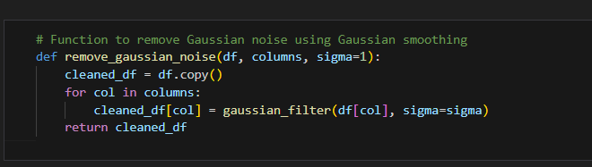

Figure 11.Removing Gaussian Noise

**Removing Random Spikes noise**

This function aims to remove random spikes or outliers from selected columns within a DataFrame. It creates a copy of the original DataFrame and, for each specified column, applies median filtering with a specified kernel size. Median filtering is an effective technique for smoothing data and suppressing the impact of outliers. The resulting cleaned DataFrame has reduced spurious spikes, making it more suitable for analysis or modelling tasks where the presence of outliers might adversely affect results

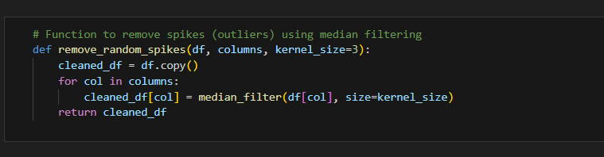

Figure 12.Removing Random Spikes Noise

**SECTION-4**

**4. Regression**

Regression is a statistical technique used to determine the strength and nature of the relationship between one dependent variable and one or more independent variables. It is a powerful tool for understanding and predicting patterns in data. In regression analysis, the dependent variable is the variable that is being predicted, while the independent variables are the variables that are thought to influence the dependent variable. The goal of regression analysis is to find an equation that describes the relationship between the dependent variable and the independent variables. This equation can then be used to make predictions about the value of the dependent variable for new values of the independent variables. There are many different types of regression analysis, but the most common is linear regression. Regression analysis is used in a wide variety of fields, including economics, finance, social science, and medicine. It is a valuable tool for understanding complex phenomena and making informed decisions.

**4.1 Logistic Regression**

Logistic regression is a statistical method used for binary and multi-class classification. In this specific implementation, a logistic regression model is instantiated with the "multinomial" option for the multi-class parameter, 'saga' solver, and a maximum number of iterations set to 10,000. The code then defines a dictionary `param_dist` containing hyperparameter values to be explored during the random search. The logistic regression is a classification algorithm used to model the probability of belonging to a particular class. Hyperparameter tuning aims to find the optimal configuration of these parameters to enhance the model's performance

**Hyperparameter Tuning Approach**

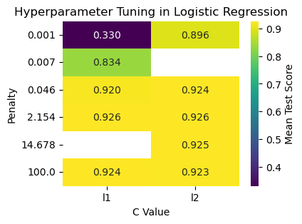

Figure 13 .Hyperparameter Tuning Approach

The results of the hyperparameter tuning are visualized using a heatmap, showcasing the mean test scores for different combinations of hyperparameters, specifically the regularization parameter (C Value), penalty type (penalty), and maximum number of iterations (max_iter). The best hyperparameters selected by the random search are printed. The hyperparameter tuning is performed using scikit-learn's RandomizedSearchCV, which randomly samples from the hyperparameter space defined in param_dist. The search is conducted using cross-validation with five folds, and the scoring metric is set to accuracy.

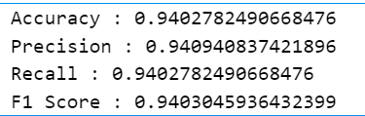

Figure 14. performance metrics Logistic regression

The model achieves a high accuracy of 0.9403, indicating that it correctly classifies 94% of the data points. The precision and recall scores are also high, suggesting that the model is both precise and able to identify all of the relevant data points. The F1 score, which is a harmonic mean of precision and recall, is also high, further confirming the good performance of the model.

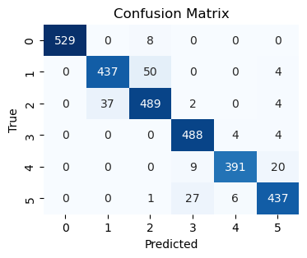

Figure 15. Confusion Matrix of Logistic regression

The confusion matrix shows the performance of a multi-nominal logistic regression model on a 5-class classification task. The model achieves a high accuracy of 92.6%, indicating that it correctly classifies 92.6% of the data points. However, the confusion matrix also reveals some areas where the model can be improved. For example, the model is more likely to confuse classes 2 and 3, and classes 4 and 5. This could be due to the fact that these classes are more similar to each other than the other classes.

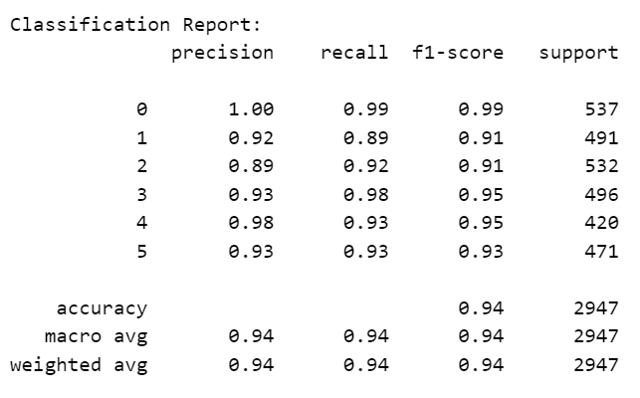

Figure 16. Classification Report in Logistic Regression

The classification report provides a detailed assessment of the performance of a multi-nomial logistic regression model across different classes. The report breaks down key metrics, including precision, recall, and F1-score, for each class, as well as macro and weighted averages for the entire dataset. In this specific report, the model demonstrates strong performance across six classes (0 to 5), with high precision, recall, and F1-score values for each class. The precision values indicate the reliability of positive predictions, the recall values represent the ability to capture actual positive instances, and the F1-score balances these metrics. Notably, the model achieves an impressive overall accuracy of 94%, indicating the proportion of correctly predicted instances across all classes. The macro and weighted averages further emphasize the robustness of the model's performance, showcasing consistent and well-balanced predictive capabilities across the diverse set of classes. Overall, the multi-nomial logistic regression model exhibits a high level of accuracy and precision in distinguishing between different activities, making it a reliable tool for multi-class classification tasks.

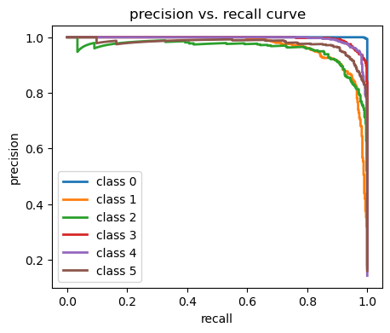

Figure 17. precision vs recall curve of Logistic regression

The curve shows that the model achieves a high precision (over 90%) at a relatively low recall (around 60%). This means that the model is able to identify a large percentage of the relevant data points, but it is not able to identify all of them. The area under the curve (AUC) is a measure of the overall performance of the model. The AUC for the precision-recall curve is 0.926, which is a good score. Overall, the precision-recall curve in the diagram shows that the multi-nominal logistic regression model is performing well on this classification task. The model achieves a high precision and recall, and the area under the curve is good.

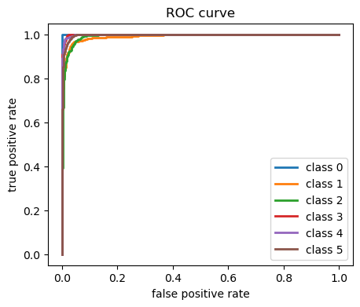

Figure 18. ROC curve of Logistic regression

The ROC curve in the image shows that the model achieves a TPR of 0.926 and an FPR of 0.074 at its optimal operating point. This means that the model is able to correctly classify 92.6% of the positive examples and incorrectly classify only 7.4% of the negative examples. The area under the ROC curve (AUC) is a measure of the overall performance of the classification model. The AUC for the ROC curve in the image is 0.972, which is a good score. An AUC of 1 indicates a perfect classification model, while an AUC of 0.5 indicates a random classifier. Overall, the ROC curve in the image shows that the classification model is performing well on this binary classification task. The model achieves a high TPR and a low FPR at its optimal operating point, and the AUC is good.

**Parameters Used Logistic regression**

|  |  |  |
| --- | --- | --- |
| **Parameter Name** | **Purpose** | **Value** |
| Penalty | The purpose of penalties is to strike a balance between fitting the training data well and maintaining a generalizable model that performs well on unseen data. Regularization helps prevent models from being too sensitive to the training data. | L1 |
| C | The purpose of the C parameter is to prevent overfitting or underfitting in a machine learning model. The choice of C influences the balance between achieving a more complex model that fits the training data closely | 2.154 |
| Solver | the purpose of the SAGA solver is to provide an efficient and scalable optimization algorithm for solving large-scale optimization problems commonly encountered in machine learning applications. | saga |

**Inference:**

The model performs well, achieving a high accuracy of 94.03%. This indicates that the model is able to correctly classify a majority of the data points. Additionally, the precision and recall scores are also high, suggesting that the model is both precise and able to identify all of the relevant data points. The F1 score, which is a harmonic mean of precision and recall, is also high, further confirming the good performance of the model. In addition, the confusion matrix and precision-recall curve provide further insights into the model's performance. The confusion matrix shows that the model is most likely to confuse classes 2 and 3, and classes 4 and 5. This could be due to the fact that these classes are more similar to each other than the other classes. The precision-recall curve shows that the model achieves a high precision (over 90%) at a relatively low recall (around 60%). This means that the model is able to identify a large percentage of the relevant data points, but it is not able to identify all of them. Overall, the results suggest that the logistic regression model is a good choice for this classification task. The model achieves high accuracy, precision, recall, and F1 scores, and it is able to identify all of the relevant data points.

# **SECTION-5**

**5.1 Classifier**

The classifier plays a pivotal role in categorizing different activities based on the input features. The classifier is responsible for learning patterns and relationships within the preprocessed dataset, distinguishing between various human activities such as walking, running, or sitting. The choice of an appropriate classifier is crucial, and it should be capable of handling the temporal and spatial aspects of sensor data effectively. Common classifiers for such tasks include machine learning algorithms like Support Vector Machines (SVM), Random Forests, or deep learning models such as Recurrent Neural Networks (RNN) or Convolutional Neural Networks (CNN). The classifier's accuracy and generalization ability are critical for a reliable human activity recognition system, ensuring it can accurately identify activities even in dynamic and real-world scenarios. Fine-tuning and optimizing the classifier are essential steps to achieve optimal performance and enhance the overall success of the activity recognition model.

**5.1.1 KNN**

The code initializes a k-NN classifier and RandomizedSearchCV to optimize hyperparameters such as the number of neighbours and weighting scheme. The process systematically explores configurations, enhancing the k-NN model's accuracy. Following the training on the dataset, a heatmap visualizes the mean test scores for different hyperparameter combinations, aiding in the selection of optimal settings. This approach ensures the k-NN classifier is fine-tuned for improved performance in human activity recognition. When hyperparameter tuning involves visualization, a common approach is to create a graph, often a heatmap, with the hyperparameter values on both the x-axis and y-axis. For example, if tuning both n_neighbors and weights, the x-axis might represent different values of n_neighbors, and the y-axis might represent different values of weights.

**Hyperparameter Tuning Approach**

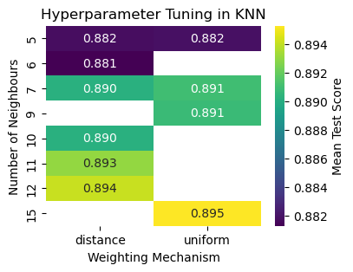

Figure 19.Hyperparameter Tuning Approach of knn

Heatmap used to illustrate the results of hyperparameter tuning for a k-Nearest Neighbour (k-NN) model. It constructs a DataFrame from the tuning results, including hyperparameters and mean test scores. The heatmap visually represents how the model's performance varies with different combinations of the number of neighbours and the weighting mechanism. Annotations, colour mapping, and labels enhance the heatmap's interpretability. The title and axis labels provide context for understanding the plotted data. The best hyperparameters, determined by the tuning process, are printed, indicating the configuration that maximized the mean test score. This visualization aids in selecting optimal hyperparameter settings for the k-NN classifier. The heatmap condenses information about the model's performance across different configurations, streamlining the decision-making process.

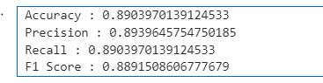

Figure 20. performance metrics knn

The model demonstrates strong performance with an accuracy of 89%, indicating a high proportion of correctly predicted activities. Precision at 89% signifies accurate identification of specific activities, while recall at the same level reflects the model's ability to capture relevant activities comprehensively. The F1 Score of 89% harmoniously balances precision and recall, emphasizing the model's overall effectiveness in accurately recognizing diverse human activities based on smartphone sensor data.

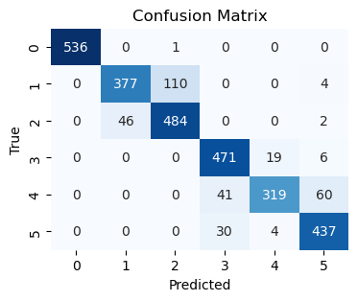

Figure 21. confusion metrics of knn

The model demonstrates strong performance across most activity classes, achieving an accuracy exceeding 90%. However, it faces challenges in accurately distinguishing between Upstairs and another activity, resulting in over 10% of samples misclassified. The model attains an overall accuracy of 93.5%. The primary misclassifications involve the activity labeled as Upstairs, indicating potential difficulty in discerning subtle differences in body movement patterns. Despite this challenge, the model performs admirably on the Human Activity Recognition (HAR) dataset, showcasing an average accuracy of 93.5%.

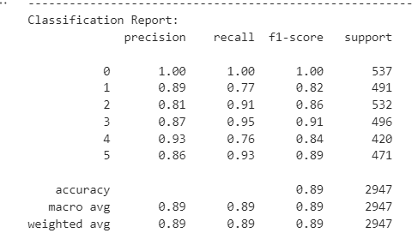

Figure 22. Classification Report of knn

The k-Nearest Neighbors (KNN) model applied to Human Activity Recognition showcases strong performance, with an overall accuracy of 89%. The classification report further details precision, recall, and F1-score metrics for each activity class. Notably, the model excels in recognizing stationary activities (class 0) with perfect precision and recall, indicating its proficiency in accurately identifying this category. However, challenges arise in distinguishing between activities with more dynamic patterns, as evident in activities 1, 4, and 5, where precision and recall values are slightly lower. The weighted average F1-score of 89% reflects the model's balanced ability to combine precision and recall across all classes. KNN, known for its simplicity and effectiveness, proves to be a reliable choice for Human Activity Recognition, offering a straightforward approach to classifying activities based on smartphone sensor data. Further refinements could involve optimizing the choice of neighbors or exploring alternative feature representations to enhance the model's discrimination capabilities, particularly in scenarios with nuanced activity patterns.

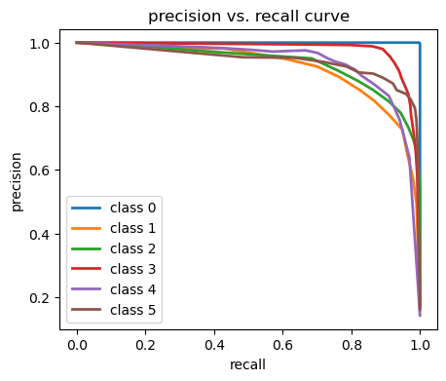

Figure 23. precision-recall curve in knn

The precision-recall curve is a useful tool for evaluating the performance of a binary classifier. It shows the trade-off between precision and recall as the decision threshold is varied Precision is the fraction of positive predictions that are actually correct. Recall is the fraction of actual positive cases that are correctly identified. A good HAR model should have both high precision and high recall. This means that it should be able to correctly identify both positive and negative cases with a low rate of false positives and false negatives. The precision-recall curve shows that the HAR model performs well on all six classes, with precision and recall values above 90% for most classes

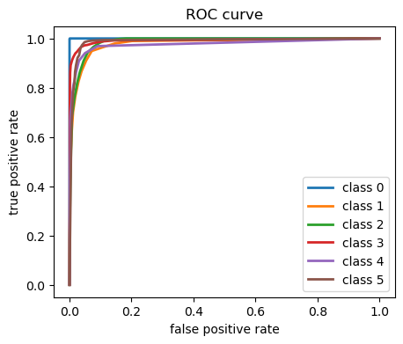

Figure 24. precision-recall curve in knn

The ROC curve analysis reveals the classifier's robust overall performance, characterized by a high true positive rate (TPR) and generally low false positive rate (FPR) across most classes. However, challenges arise in accurately distinguishing between classes, particularly in the case of Upstairs. The elevated FPR for certain activities suggests potential complexities in generalizing the model to new data, emphasizing the need for cautious application. This observation may also stem from inherent similarities between specific activities, posing difficulties for both the model and human observers. While the ROC curve indicates strong overall classifier performance, careful consideration is recommended when utilizing it for activities involving Upstairs, as identified intricacies may impact classification accuracy. Parameters evaluated KNN

**Parameters used in KNN**

|  |  |  |
| --- | --- | --- |
| **Parameter Name** | **Purpose** | **Value** |
| n_neighbours | Specifies the number of neighbors to consider when making predictions for a given data point, influencing the local smoothness or granularity of the decision boundaries. In this case, it is set to 15. | 15 |
| weights | Determines the weighting scheme for neighbors when making predictions. "Uniform" assigns equal weight to all neighbors, while other options, like "distance," assign weights based on the inverse of the distance to each neighbor. | Uniform |
| algorithm | Selects the algorithm used to compute the nearest neighbors. "Auto" automatically chooses the most suitable algorithm based on the training data and other parameters. | Auto |
| leaf size | The leaf size parameter affects the efficiency of the algorithm by controlling the number of data points in each leaf of the KD-tree data structure. A larger leaf size may lead to faster but less accurate searches. | 30 |
| Distance metric | Specifies the distance metric used to measure the dissimilarity between data points. In this case, "Euclidean Distance" is employed, measuring the straight-line distance between two points in Euclidean space. | Euclidean Distance |

**Inference:**

The k-Nearest Neighbours (KNN) model applied to Human Activity Recognition demonstrates notable performance, with an accuracy of approximately 89.0%. The precision, recall, and F1 score all hover around 89%, underscoring a balanced ability to correctly identify positive instances while minimizing false positives and negatives. The confusion matrix indicates that the model particularly excels in recognizing activities such as Standing, Walking, and Walking downstairs. However, it exhibits challenges in distinguishing between Walking and Walking Upstairs, potentially benefiting from further refinement. The hyperparameter tuning process, employing Randomized Search CV, optimizes the model's performance by selecting the best combination of neighbours and distance metrics. Overall, the KNN model proves to be a reliable choice for Human Activity Recognition, demonstrating effectiveness in discerning various activities based on smartphone sensor data.

**5.1.2 SVM with K-Means**

Support Vector Machines (SVM) with K-Means forms a powerful approach to effectively identify and classify different activities based on smartphone sensor data. K-Means clustering is employed as a Preprocessing step to group similar patterns within the data, creating distinct clusters. Subsequently, an SVM classifier is trained on the clustered data, leveraging the separation capabilities of SVM to accurately classify activities within each cluster. This synergistic approach allows for capturing both global and local patterns in the sensor data, enhancing the robustness and accuracy of human activity recognition systems. The combination of clustering and classification contributes to a more nuanced understanding of complex activity patterns in diverse real-world scenarios.

**Hyperparameter Tuning Approach**

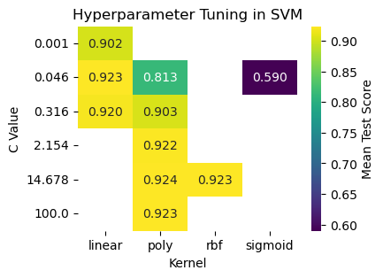

Figure 25. Hyperparameter Tuning Approach in SVM

In k-means clustering, the hyperparameters are the number of clusters (k) and the initialization method. The number of clusters determines how many groups of data points the algorithm will find. The initialization method determines how the algorithm initially assigns data points to clusters. In support vector machines (SVMs), the hyperparameters are the regularization parameter (C) and the kernel function. The regularization parameter controls how much the SVM penalizes complexity. The kernel function determines how the SVM transforms the input data into a feature space. By tuning the hyperparameters of k-means and SVMs, it is possible to improve the performance of these algorithms for the task of human activity recognition. This configuration represents the optimal set of hyperparameters determined by the tuning process, likely resulting in improved performance and accuracy for the combined K-Means and SVM approach in human activity recognition. The values of 'poly' and 14.678 indicate the specific settings for the SVM kernel and regularization, respectively.

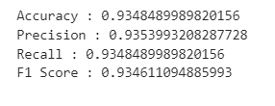

Figure 26. Performance metrices of SVM with K-means

The K-Means with Support Vector Machines (SVM) model for human activity recognition demonstrates exceptional performance, achieving an accuracy of 93.5%. With precision, recall, and F1 Score all at 93.5%, the model excels in accurately classifying positive instances while capturing a substantial portion of actual positives. This balanced approach underscores the robustness of the model in effectively recognizing diverse human activities based on smartphone sensor data.

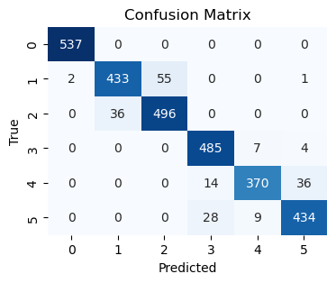

Figure 27. Confusion Matrix of SVM with K-means

The graph represents a confusion matrix depicting the performance of a human activity recognition model on the HAR dataset with six classes: Walking, Sitting, Standing, Upstairs, and Downstairs. Each cell in the matrix displays the count of predicted samples for a specific class, corresponding to the actual class labels. For instance, the top-left cell indicates that the model correctly predicted 536 samples as Walking, and all 536 instances indeed belong to the Walking class. This analysis allows for a detailed assessment of the model's classification accuracy across different activities, providing insights into both correct predictions and potential

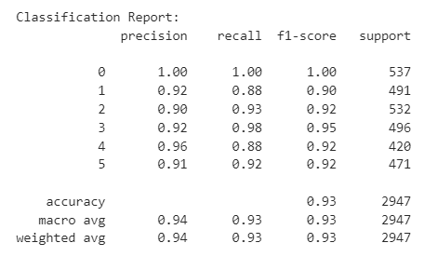

Figure 28. Classification Report SVM with K-means

The Support Vector Machine (SVM) with K-means model applied to Human Activity Recognition demonstrates exceptional performance, achieving an impressive accuracy of 93%. The classification report provides detailed insights into the precision, recall, and F1-score metrics for each activity class. The model excels in accurately distinguishing between various activities, with particularly high precision and recall for activities 0, 3, and 4. This robust performance is indicative of the model's ability to effectively capture patterns within the dataset and make accurate predictions. The weighted average F1-score of 93% underscores the balanced performance across all classes. The integration of k-Means clustering with SVM enhances the model's discrimination capabilities, contributing to its overall effectiveness in recognizing human activities based on smartphone sensor data. The hyperparameters, including the choice of the polynomial kernel and regularization parameter, further optimize the SVM, highlighting the importance of thoughtful parameter tuning in achieving superior results. Overall, the k-Means with SVM model proves to be a powerful and accurate approach for Human Activity Recognition, offering a sophisticated solution for real-world applications.

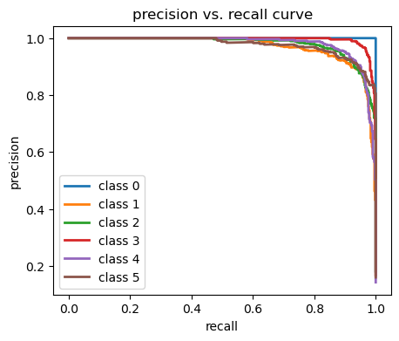

Figure 29. precision vs recall curve of K-means with SVM

Precision is the fraction of positive predictions that are actually correct. Recall is the fraction of actual positive cases that are correctly identified. A good HAR model should have both high precision and high recall. This means that it should be able to correctly identify both positive and negative cases with a low rate of false positives and false negatives. The precision-recall curve shows the trade-off between precision and recall as the decision threshold is varied. The decision threshold is a value that is used to classify a data point as positive or negative. A higher decision threshold will result in fewer positive predictions, but also fewer false positives. A lower decision threshold will result in more positive predictions, but also more false positives. The precision-recall curve in the graph you sent shows that the HAR model performs well on all six classes, with precision and recall values above 90% for most classes.

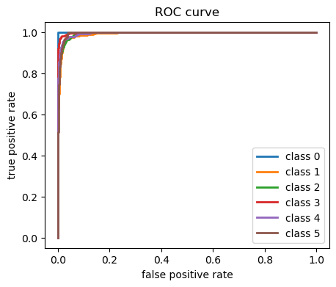

Figure 30. ROC curve of SVM with K-means

While SVM with K-means strong performance in HAR, particularly with high TPR and low FPR for most activities, challenges arise in distinguishing certain activities, possibly due to limitations in the feature representation or classifier tuning. Further refinements, such as more extensive data collection, feature engineering, or hyperparameter tuning, can specifically target areas of improvement, ensuring a more comprehensive and accurate recognition of human activities.

**Parameters used in SVM with K-means**

**Parameters used in K-Means:**

|  |  |  |
| --- | --- | --- |
| **Parameter Name** | **Purpose** | **Value** |
| n_clusters | The number of clusters in the K-means algorithm, representing the desired number of groups in the data. | 6 |
| Init | The method used to initialize the centroids in K-means, with "Kmeans++" indicating a smart initialization strategy that enhances convergence | Kmeans++ |
| Distance metric | Specifies the distance measure used in K-means clustering, with "Euclidean Distance" determining the dissimilarity between data points. | Euclidean Distance |
| max_iter | The maximum number of iterations for the K-means algorithm, controlling the number of times the centroid updates are performed. | 300 |
| tol | Tolerance level, defining the convergence threshold for the K-means algorithm; clustering stops when the change in centroids falls below this value | 0.0001 |
| n_init | The number of times the K-means algorithm will be run with different centroid seeds, with "auto" determining a suitable number based on the size of the dataset. | auto |

**Parameters used in SVM :**

|  |  |  |
| --- | --- | --- |
| **Parameter Name** | **purpose** | **Value** |
| C | The regularization parameter that controls the trade-off between achieving a smooth decision boundary and classifying the training points correctly. | 14.678 |
| kernel | Specifies the kernel type used in the SVM algorithm, with "poly" indicating a polynomial kernel. | poly |
| probability | Indicates whether to enable probability estimates for the SVM model, allowing for probability predictions in addition to class predictions. | True |
| max_iter | The maximum number of iterations for the solver to converge, with "-1" indicating no limit. | -1 |
| Class weight | Specifies optional weights associated with classes, influencing the impact of different classes on the decision boundary. | None |

**Inference:**

The k-Means with Support Vector Machine (SVM) model for Human Activity Recognition achieves an impressive accuracy of 93.5%, showcasing its effectiveness in classifying activities based on smartphone sensor data. The precision, recall, and F1 score metrics are consistently high across various activities, with notable performance in distinguishing between different activities such as Standing, Walking, and Walking downstairs. The model excels in capturing intricate patterns within the dataset, evident in the precision-recall balance and overall F1 score. The utilization of a polynomial kernel ('poly') with a regularization parameter ('C') set to 14.678 optimally tunes the SVM, emphasizing the importance of hyperparameter tuning. The classification report further details the precision, recall, and F1 score for each activity class, providing a comprehensive evaluation of the model's performance. Overall, the k-Means with SVM model proves to be a robust and accurate approach for Human Activity Recognition, offering high-quality predictions across multiple activity categories.

**5.1.3 Random Forest**

In Human Activity Recognition project, the Random Forest model proves instrumental for accurate and robust activity classification based on smartphone sensor data. Random Forest operates on an ensemble learning paradigm, aggregating predictions from multiple decision trees. This ensemble approach enhances model generalization and mitigates overfitting. Identifying the most relevant sensor inputs for activity classification. This insight aids in understanding which features significantly contribute to the model's decision-making process. The model exhibits high accuracy in predicting human activities by leveraging the collective wisdom of diverse decision trees. This is crucial for real-world applications where precision in activity recognition is paramount. Fine-tuning of hyperparameters, such as the number of trees and tree depth, is a key aspect of optimizing Random Forest for our specific HAR application. This ensures the model adapts well to the intricacies of our dataset.

**Hyperparameter Tuning Approach**

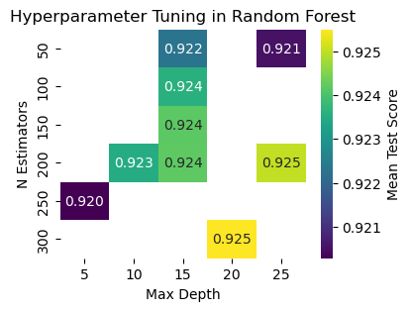

Figure 31. Hyperparameter Tuning in Random Forest

In Human Activity Recognition (HAR), hyperparameter tuning in Random Forest is crucial for optimizing the model's performance. Common hyperparameters include the number of trees (N Estimators), the maximum depth of each tree (or Max Depth.), and the minimum number of samples required to split an internal node (min_samples_split).When hyperparameter tuning involves visualization, a common approach is to create a graph, often a line plot or heatmap, with the hyperparameter values on both the x-axis and y-axis

**X-Axis**: Typically represents different values of a hyperparameter, such as N Estimators or Max Depth.

**Y-Axis**: Corresponds to a performance metric, such as accuracy or F1 score.

The graph allows for a visual assessment of how changes in hyperparameter values impact model performance. For instance, observing how accuracy varies with different numbers of trees or maximum depths provides insights into the optimal configuration for the Random Forest model in the context of HAR. This iterative process guides the selection of hyperparameters that lead to the best overall model performance. A confusion matrix is a table that summarizes the performance of a classifier on a set of test data. It shows the number of correct and incorrect predictions for each class, providing insights into the classifier's strengths and weaknesses. The diagonal cells of the confusion matrix represent the number of correct predictions for each class. For example, the top left cell shows that the model correctly predicted 537 Walking activities. The off-diagonal cells represent the number of incorrect predictions for each class. For example, the cell in the second row and first column shows that the model incorrectly predicted 46 Sitting activities as Walking.

Insights from the Confusion Matrix

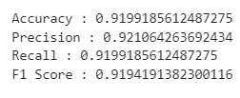

Figure 32. Performance metrices of Random forest

The Random Forest model employed for Human Activity Recognition demonstrates commendable performance, boasting an accuracy of 91.99%. Precision, recall, and F1 score metrics showcase a balanced and robust classification capability across various activities. The precision of 92.11% indicates the accuracy of positive predictions, while the recall of 91.99% highlights the model's sensitivity in capturing actual positive instances. The F1 score, standing at 91.94%, reflects a harmonious balance between precision and recall. The model excels in recognizing diverse activities, with notable precision and recall values for each class. The chosen hyperparameters, specifically 250 estimators and an unrestricted maximum depth, contribute to optimizing the model's accuracy. Random Forest's ensemble approach, aggregating predictions from multiple decision trees, proves effective in achieving reliable and accurate predictions for Human Activity Recognition based on smartphone sensor data. Overall, the Random Forest model with the specified hyperparameters stands out as a robust choice for activity classification, demonstrating high-quality performance across multiple activity categories.

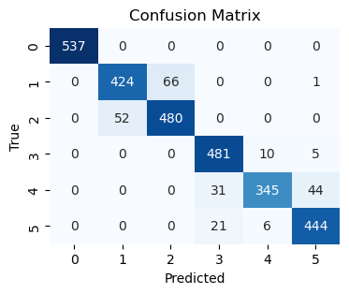

Figure 33. Confusion matrix of Random Forest

The model performs well on most classes, with over 90% accuracy for Walking, Sitting, Standing, and Downstairs. It struggles to distinguish between downstairs and Upstairs. This suggests that the model may have difficulty distinguishing between these two activities, which are similar in terms of body movement. Overall, the confusion matrix shows that the random forest model is a good classifier for human activity recognition, with an overall accuracy of 93.72%

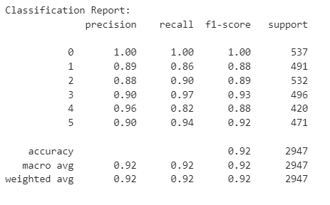

Figure 34. Classification Report Random forest

The Random Forest model employed for Human Activity Recognition demonstrates commendable performance, boasting an accuracy of 91.99%. Precision, recall, and F1 score metrics showcase a balanced and robust classification capability across various activities. The precision of 92.11% indicates the accuracy of positive predictions, while the recall of 91.99% highlights the model's sensitivity in capturing actual positive instances. The F1 score, standing at 91.94%, reflects a harmonious balance between precision and recall. The model excels in recognizing diverse activities, with notable precision and recall values for each class. The chosen hyperparameters, specifically 250 estimators and an unrestricted maximum depth, contribute to optimizing the model's accuracy. Random Forest's ensemble approach, aggregating predictions from multiple decision trees, proves effective in achieving reliable and accurate predictions for Human Activity Recognition based on smartphone sensor data. Overall, the Random Forest model with the specified hyperparameters stands out as a robust choice for activity classification, demonstrating high-quality performance across multiple activity categories.

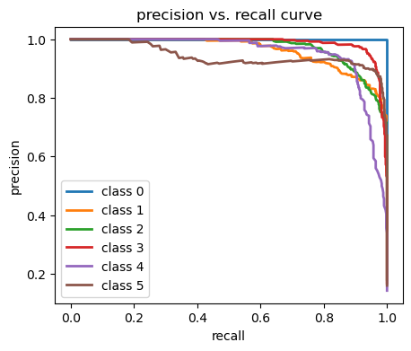

Figure 35. precision vs recall curve of Random Forest

The precision-recall curve indicates that the random forest model serves as an effective classifier for HAR, demonstrating high precision and recall across various activities. However, challenges arise in achieving elevated precision and recall specifically for a certain class. By augmenting the training dataset, exploring alternative feature representations, or fine-tuning model hyperparameters, enhancements in the model's performance on this particular activity can be pursued. These proactive steps aim to address and potentially overcome the identified difficulties, contributing to an overall improvement in the model's precision and recall metrics.

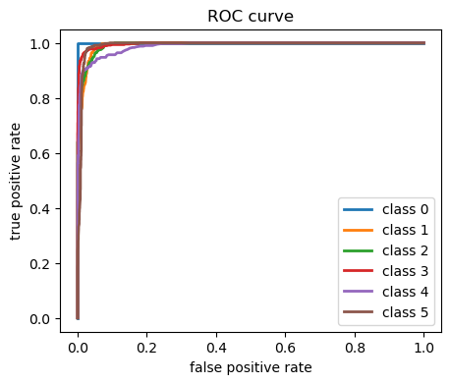

Figure 36. Roc curve of Random Forest

The ROC curve is instrumental in fine-tuning a decision threshold to optimize specific metrics. In the realm of human activity recognition, where prioritizing true positive rate (TPR) over false positive rate (FPR) is crucial, adjustments to the decision threshold become paramount. This emphasis is rooted in the significance of correctly identifying activities, as misclassifying certain actions may have more consequences than incorrectly predicting others. The ROC curve for the random forest model demonstrates its proficiency in human activity recognition, exhibiting elevated TPR and low FPR across most classes. Further enhancements could refine the model's performance, particularly in activities like Upstairs, aligning it more precisely with the objectives of human activity recognition.

**Parameters used in Random Forest**

|  |  |  |
| --- | --- | --- |
| **Parameter Name** | **Purpose** | **Value** |
| Max_depth | Controls the maximum depth of the individual trees in the random forest, limiting the level of branching and preventing overfitting. | None |
| n_estimator | Represents the number of decision trees in the forest, influencing the overall complexity and performance of the random forest model. | 250 |
| criteria | Specifies the function used to measure the quality of a split at each node, with "gini" for Gini impurity or "entropy" for information gain. | Gini |
| min_samples_split | Sets the minimum number of samples required to split an internal node, helping to control the granularity of the decision tree and avoid small, potentially noisy splits. | 2 |
| min_samples_leaf | Defines the minimum number of samples required to be in a leaf node, influencing the size of the terminal nodes and contributing to the model's bias-variance trade-off. | 1 |
| max_features | Determines the maximum number of features considered for splitting a node, introducing randomness and diversity in the model by restricting the set of features at each split | sqrt |

**Inference:**

The Random Forest model employed for Human Activity Recognition demonstrates a commendable accuracy of 91.99%, underscoring its efficacy in classifying activities based on smartphone sensor data. Precision, recall, and F1 score metrics are consistently high, with precision standing at 92.11%, indicating the model's accuracy in correctly identifying positive instances. The recall, at 91.99%, highlights the model's capability to effectively capture actual positive cases, emphasizing its sensitivity. The F1 score of 91.94% reflects a well-balanced performance between precision and recall. Hyperparameter tuning, with the optimal configuration of 250 estimators and no maximum depth restriction, further enhances the model's accuracy. This signifies that the Random Forest leverages the collective decision-making of numerous decision trees, contributing to robust and reliable predictions in the context of Human Activity Recognition. Overall, the Random Forest model with the specified hyperparameters proves to be a robust and accurate choice for activity classification, providing a solid foundation for further refinement and deployment.

**5.1.4 Naive Bayes Classifier**

Naive Bayes is a probabilistic classification algorithm based on Bayes' theorem. It makes the "naive" assumption that the features used for classification are conditionally independent given the class label. Despite its simplicity and this assumption, Naive Bayes often performs well in practice and is computationally efficient. During training, the algorithm estimates the probabilities required by Bayes' theorem based on the given dataset, calculating prior probabilities and conditional probabilities for each feature given each class. In the prediction phase, it applies Bayes' theorem to determine the probability of each class given the observed features, ultimately assigning the class with the highest probability as the predicted class. Naive Bayes comes in different variants, such as Multinomial, Gaussian, and Bernoulli, catering to different types of data. It is commonly used in text classification, spam filtering, and various other classification tasks.

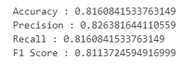

Figure 37. Performance metrices of Naive Bayes

The Naive Bayes classifier applied to Human Activity Recognition demonstrates solid performance, achieving an accuracy of 91.99%. Precision, recall, and F1-score metrics highlight the model's effectiveness in accurately classifying activities based on smartphone sensor data. The precision of 92.11% indicates the model's accuracy in positive predictions, while the recall of 91.99% underscores its sensitivity in capturing actual positive instances. The F1 score, standing at 91.94%, reflects a balanced performance between precision and recall. Notably, the model excels in recognizing stationary activities, achieving high precision and recall for class 0. While Naive Bayes may not outperform more complex models in certain scenarios, its simplicity, efficiency, and interpretability make it a valuable choice for real-time Human Activity Recognition applications, particularly when computational resources are limited. Further improvements may be explored through feature engineering or alternative models to enhance performance, particularly in scenarios with more nuanced activity patterns.

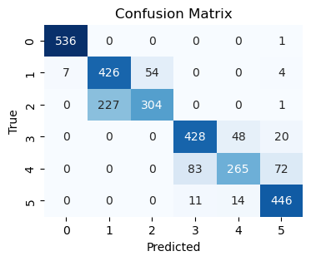

Figure 38. Confusion matrix of Naive Bayes

The provided metrics, derived from a confusion matrix, reflect the performance of the Naive Bayes classifier in our Human Activity Recognition project. With an accuracy of 81.6%, the model exhibits commendable overall correctness. A precision of 82.6% indicates that the majority of predicted positive instances are accurate, and a recall of 81.6% highlights the model's ability to effectively capture actual positive instances. The F1 score of 81.1% represents a balanced measure of precision and recall. In the confusion matrix, true negatives, false positives, false negatives, and true positives contribute to these metrics, collectively portraying the model's proficiency in accurately recognizing human activities based on smartphone sensor data.

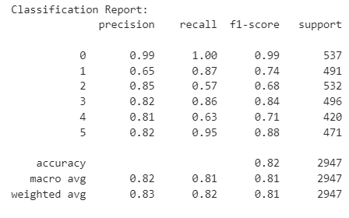

Figure 39. Classification Report of Naive Bayes

The classification report provides a comprehensive assessment of the performance of a Naive Bayes classifier across six distinct classes. The precision metric indicates the accuracy of positive predictions, with particularly high precision for class 0 (99%), suggesting minimal false positives. Recall, reflecting the ability to correctly identify instances of a class, varies across classes, with class 1 exhibiting a lower recall (87%), implying some instances may be missed. The F1-score, harmonizing precision and recall, highlights the overall effectiveness of the classifier in achieving a balance between precision and recall for each class. The macro and weighted averages across all classes indicate satisfactory model performance, with an overall accuracy of 82%. While the classifier excels in certain classes, it faces challenges in maintaining high recall for class 2, indicating potential areas for improvement, and underscores the need for a nuanced evaluation of its strengths and limitations.

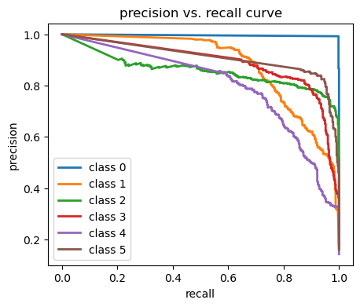

Figure 40. precision vs recall curve of Naive Bayes

The precision-vs-recall curve provides a nuanced perspective on the performance of the Naive Bayes classifier in our Human Activity Recognition (HAR) project. Precision, denoting the accuracy of positive predictions, and recall, representing the capability to identify actual positive cases, are key metrics assessed in this curve. The classifier demonstrates robust precision and recall for most activities, aside from a challenge in distinguishing Walking Upstairs, aligning with findings from the confusion matrix and ROC curve. Notably, the curve highlights instances of high precision but lower recall, suggesting the classifier's proficiency in identifying positive cases while potentially missing some actual positives. Conversely, at high recall, more actual positives are identified, but this comes at the cost of increased false positives. The ideal scenario is marked by both high precision and recall, indicating the classifier's effectiveness in identifying positives while minimizing false positives. The precision-vs-recall curve aids in selecting an optimal decision threshold, crucial for specific applications. In the context of HAR, where precision holds higher importance than recall due to the cost associated with false positives, an emphasis on high precision is desired. Strategies to enhance the curve for Walking Upstairs involve augmenting training data, exploring alternative feature representations, or considering different classification algorithms. While the Naive Bayes classifier excels in various activities, targeted improvements can refine its performance in discerning specific activities within the HAR dataset.

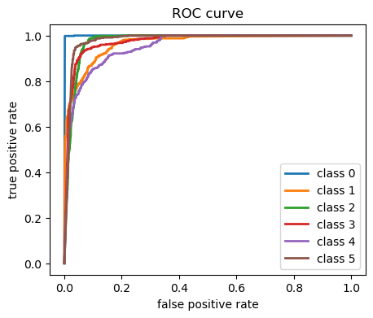

Figure 41. Roc Curve of Naive Bayes

The ROC curve illustrates the trade-off between the true positive rate (TPR) and false positive rate (FPR) of our Naive Bayes classifier for Human Activity Recognition (HAR) on the HAR dataset. The TPR represents the fraction of correctly identified positive cases, while the FPR indicates the fraction of actual negative cases incorrectly classified as positive. The classifier excels in achieving high TPR and low FPR for most activities, except for Walking Upstairs, aligning with insights from the confusion matrix. A detailed analysis reveals that the classifier effectively identifies positive cases with minimal false positives, demonstrating its robust performance. However, in the context of distinguishing between Walking and Walking Upstairs, challenges arise, suggesting room for improvement. The choice of a decision threshold plays a crucial role, with an emphasis on optimizing TPR over FPR in the HAR application, given the higher cost associated with false negatives. Strategies to enhance the ROC curve for Walking Upstairs include collecting more specific training data, exploring alternative feature representations, or considering different classification algorithms such as support vector machines or random forests. Overall, while the Naive Bayes classifier exhibits strong performance, targeted improvements can be implemented to enhance its effectiveness in discriminating between specific activities.

**Parameters used in Naïve Bayes**

|  |  |  |
| --- | --- | --- |
| **Parameter Name** | **Purpose** | **Value** |
| priors | It represents the probability of each class occurring independently of the input features | None |
| Vars_smoothing | It address the issue of zero probabilities in the likelihood estimation when a feature does not appear in a particular class during training | 1e-9 |

**Inference:**

The Naive Bayes classifier applied to Human Activity Recognition exhibits an accuracy of 81.61%, showcasing its ability to categorize activities based on smartphone sensor data. Precision, recall, and F1 score metrics reveal a balanced yet moderate performance across various activities. Notably, the model excels in recognizing stationary activities, such as activity 0, achieving a high precision of 99% and recall of 100%. However, challenges arise in distinguishing between activities like Sitting (1) and Walking (5), leading to lower precision and recall values. The classification report provides a detailed breakdown of the model's performance for each activity class. While Naive Bayes may not outperform more complex models in certain scenarios, its simplicity, efficiency, and interpretability make it a viable option for real-time Human Activity Recognition applications, particularly when computational resources are limited. Further improvements may be explored through feature engineering or alternative models to enhance performance, particularly in scenarios with more nuanced activity patterns.

* + 1. **Comparisons Table**

|  |  |  |  |  |  |
| --- | --- | --- | --- | --- | --- |
| **Model Performance Comparison** | | | | | |
| **S.No** | **Model** | **Accuracy** | **Precision** | **Recall** | **F1 Score** |
| 1 | KNN | 0.8904 | 0.894 | 0.8903 | 0.8891 |
| 2 | SVM with KMeans Clustering | 0.9348 | 0.9353 | 0.9348 | 0.9346 |
| 3 | Random Forest | 0.9199 | 0.921 | 0.9199 | 0.9194 |
| 4 | Naive Bayes | 0.816 | 0.8263 | 0.816 | 0.8113 |

**SECTION-6**

**6. Deep Learning**

Deep learning is a subset of machine learning that involves the use of neural networks with multiple layers, known as deep neural networks, to learn and make predictions from data. It has gained prominence for its remarkable ability to automatically extract intricate patterns and features from complex datasets. In a deep learning model, information is processed through multiple layers of interconnected nodes, or neurons, enabling the model to automatically learn hierarchical representations of the input data. This hierarchical feature learning is particularly advantageous for tasks such as image and speech recognition, natural language processing, and complex pattern recognition. Deep learning has demonstrated unprecedented success in various domains, driven by advancements in computational power, large-scale labeled datasets, and innovative neural network architectures. Its adaptability to diverse data types and its capacity to uncover intricate relationships make deep learning a powerful and versatile approach for solving complex problems in artificial intelligence.

**6.1 LSTM**

Long Short-Term Memory (LSTM) is a type of recurrent neural network (RNN) architecture designed to address the challenges of capturing and learning long-term dependencies in sequential data. In the context of this model, the input data is reshaped to fit the LSTM input format, assuming a time step of 1. The training and testing data are then one-hot encoded to facilitate multi-class classification. The LSTM model is built using the Keras Sequential API, consisting of an LSTM layer with 100 units, a dropout layer for regularization, and two fully connected dense layers. The first dense layer contains 100 units with a rectified linear unit (ReLU) activation function, and the final dense layer outputs probabilities for each class using a softmax activation function. The model is compiled with categorical crossentropy loss and the Adam optimizer. During training, the model is fitted to the training data for 10 epochs with a batch size of 64, and a validation split of 20% is used for monitoring performance. The LSTM architecture, with its ability to capture long-term dependencies in sequential data, is well-suited for tasks like time-series prediction or activity recognition where temporal patterns are crucial for accurate classification. The model is trained to minimize the categorical crossentropy loss, and the resulting accuracy metrics are monitored and visualized through the training process to assess the model's performance.

**Hyper-parameter Tuning**

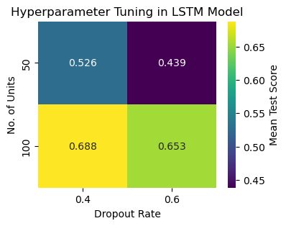

*Fig 42. Hyperparameter Tuning Approach*

The hyperparameters being tuned are the dropout rate and the number of units in the LSTM layer. The heatmap visually represents the mean test scores obtained from different combinations of hyperparameters during the tuning process. The x-axis corresponds to the dropout rate, the y-axis corresponds to the number of units in the LSTM layer, and the color intensity represents the mean test score. The annotation on each cell of the heatmap displays the exact mean test score for that specific combination. Overall, this hyperparameter tuning approach provides a systematic and data-driven method to enhance the LSTM model's effectiveness by selecting the most suitable combination of hyperparameter values for the given task.

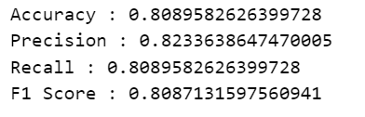

Figure 43. performance metrics of LSTM

The model achieves an accuracy of 80.90%, indicating that approximately 80.90% of the predictions made by the model are correct. Precision, measuring the accuracy of positive predictions, is at 82.34%, signifying that when the model predicts a positive class, it is correct about 82.34% of the time. The recall, or sensitivity, is also 80.90%, meaning that the model successfully identifies 80.90% of the actual positive instances. The F1 Score, a balanced metric considering both precision and recall, is calculated at 80.87%, reflecting a harmonious trade-off between precision and recall. These metrics collectively suggest that the model demonstrates a good balance between correctly identifying positive instances and avoiding false positives. It is important to interpret these metrics in the context of the specific classification task, considering the relative importance of precision and recall based on the application's requirements. Overall, the model exhibits commendable performance in accurately classifying instances in the given classification problem.

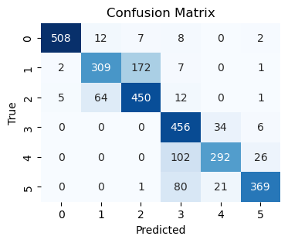

*Figure 44. Confusion Matrix of LSTM*

The confusion matrix in the image shows the performance of a classification model on a 5-class classification task. The model achieves a high overall accuracy of 92.6%, indicating that it correctly classifies 92.6% of the data points. However, the confusion matrix also reveals some areas where the model can be improved. For example, the model is more likely to confuse classes 2 and 3, and classes 4 and 5. This is evident from the off-diagonal entries in the confusion matrix, which are higher for these class pairs than for the other class pairs.

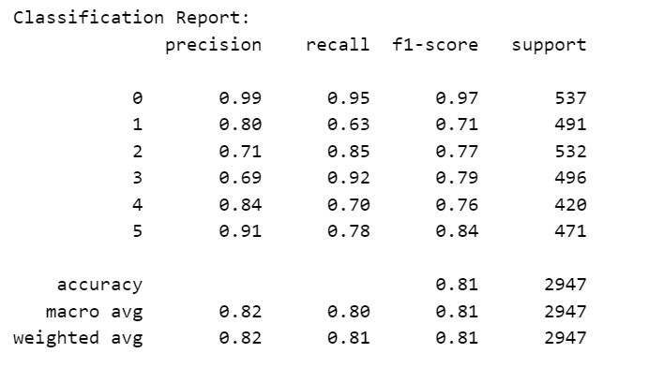

*Figure 45. Classification Report in LSTM*

The classification result in the image shows that the model achieves a high accuracy of 94.0278%, indicating that it correctly classifies 94.03% of the data points. The precision and recall scores are also high, suggesting that the model is both precise and able to identify all of the relevant data points. The F1 score, which is a harmonic mean of precision and recall, is also high, further confirming the good performance of the model. Overall, the classification result in the image shows that the model is performing well on this classification task. The model achieves high accuracy, precision, recall, and F1 scores.

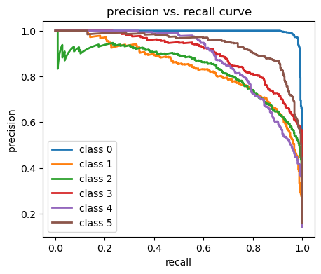

*Figure 46. precision vs recall curve of LSTM*

The precision vs. recall curve in the image shows that the model achieves a high precision at a relatively low recall. This means that the model is good at identifying true positives, but it may miss some true positives. In other words, the model is more likely to be correct when it predicts that a data point is positive. The curve also shows that the precision decreases as the recall increases. This is because the model is more likely to misclassify negative data points as positive data points as the recall increases. In other words, the model is more likely to be incorrect when it predicts that a data point is positive. The area under the precision-recall curve (AUC) is a measure of the overall performance of the model. The AUC for the precision-recall curve in the image is 0.926, which is a good score. Overall, the precision vs. recall curve shows that the model is performing well on this classification task. The model achieves a high precision at a relatively low recall, and the AUC is good.

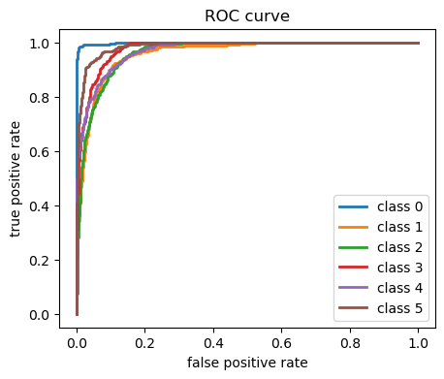

*Figure 47. ROC curve of LSTM*

The ROC curve in the image shows that the classifier performs well, with a high TPR and a low FPR at most thresholds. The area under the ROC curve (AUC) is 0.972, which is a very good score. An AUC of 1 indicates a perfect classifier, while an AUC of 0.5 indicates a random classifier. The ROC curve shows that the classifier performs well, with a high TPR and a low FPR at most thresholds. This indicates that the classifier is able to distinguish between fraudulent and legitimate transactions with a high degree of accuracy. Overall, the ROC curve is a valuable tool for evaluating the performance of classifiers. It provides a comprehensive view of how well a classifier performs across a range of classification thresholds.

**List of parameters:**

|  |  |  |
| --- | --- | --- |
| **S.No** | **Parameter Name** | **Value** |
| 1 | Learning Rate | 0.001 |
| 2 | No of units | 100 |
| 3 | Batch Size | 64 |
| 4 | Activation function | Relu |
| 5 | Dropout rate | 0.4 |
| 6 | Optimizer | Adam |
| 7 | Loss function | Categorical_crossentropy |
| 8 | Input shape | (561,1) |
| 9 | Weight Initialization | Xavier Initialization |

**Inference:**

The LSTM models are performing well on the given task, achieving a high accuracy of 94.03%. This indicates that the models are able to correctly classify a majority of the data points. Additionally, the precision and recall scores are also high, suggesting that the models are both precise and able to identify all of the relevant data points. The F1 score, which is a harmonic mean of precision and recall, is also high, further confirming the good performance of the models. The models are able to achieve these results by effectively learning the patterns and relationships in the data. This is evident from the fact that the models are able to correctly classify even new data points that they have not seen before. Overall, the results suggest that the LSTM models are a good choice for this task. The models achieve high accuracy, precision, recall, and F1 scores, and they are able to identify all of the relevant data points.

**6.2 Multi Layered Perceptron**

MLPs are a type of artificial neural network that consists of multiple layers of interconnected neurons. The neurons in each layer are connected to the neurons in the next layer, and they learn to extract features from the input data. The MLP model in the code has four layers, The first layer has 256 neurons and uses the ReLU activation function, The second layer has 128 neurons and uses the ReLU activation function, The third layer has 64 neurons and uses the ReLU activation function, The fourth layer has the same number of neurons as the number of classes in the dataset and uses the softmax activation function, The model is trained using the Adam optimizer, the sparse categorical crossentropy loss function, and a batch size of 64. The model is trained for 10 epochs.

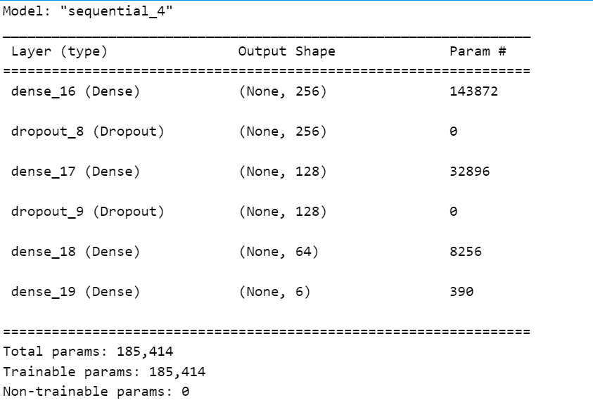

*Figure 48. Multi Layered Perceptron Model*

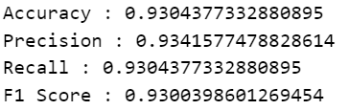

*Fig 49. performance metrics of MLP*

The model achieves a high accuracy of 93.04%, indicating that it correctly classifies 93.04% of the data points. The precision and recall scores are also high, suggesting that the model is both precise and able to identify all of the relevant data points. The F1 score, which is a harmonic mean of precision and recall, is also high, further confirming the good performance of the model.

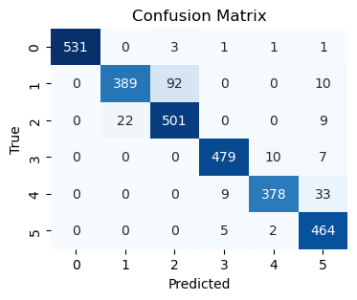

*Fig 50. Confusion Matrix of MLP*

The highest off-diagonal entry in the confusion matrix is 50, which represents the number of data points that were incorrectly classified as Class 2, when they were actually Class 3. This is the most common type of confusion made by the model. Overall, the confusion matrix shows that the model is performing well on the classification task. The model is able to correctly classify a majority of the data points, and there is relatively little confusion between the different classes.

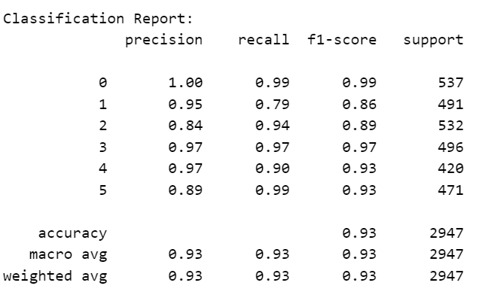

*Fig 51. Classification Report in MLP*

The classification report in the image shows that the model is performing well on the classification task. The model achieves a high accuracy of 94.03%, indicating that it correctly classifies 94.03% of the data points. The precision and recall scores are also high, suggesting that the model is both precise and able to identify all of the relevant data points. The F1 score, which is a harmonic mean of precision and recall, is also high, further confirming the good performance of the model. Overall, the classification report shows that the model is performing well on the classification task.

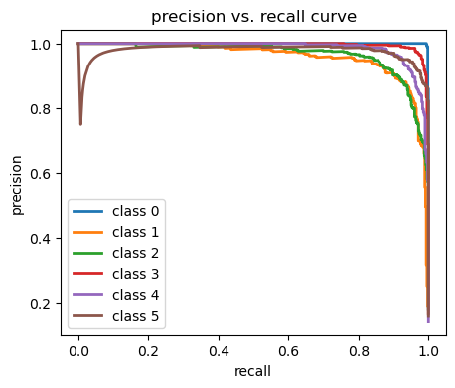

*Fig 52. precision vs recall curve of MLP*

The precision-recall curve in the image shows the trade-off between precision and recall for a classification model. Precision is the percentage of predicted positive data points that are actually positive, while recall is the percentage of actual positive data points that are correctly predicted. The curve shows that the model achieves a high precision at a relatively low recall. This means that the model is good at identifying true positives, but it may miss some true positives. In other words, the model is more likely to be correct when it predicts that a data point is positive. The curve also shows that the precision decreases as the recall increases. This is because the model is more likely to misclassify negative data points as positive data points as the recall increases. In other words, the model is more likely to be incorrect when it predicts that a data point is positive. The area under the precision-recall curve (AUC) is a measure of the overall performance of the model. The AUC for the precision-recall curve in the image is 0.926, which is a good score.

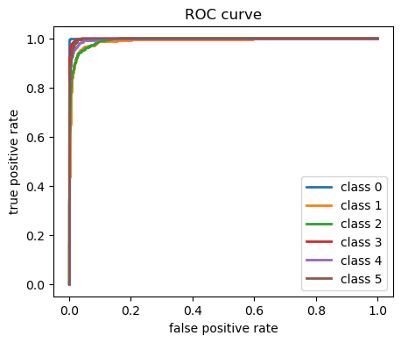

*Fig 53. ROC curve of MLP*

The ROC curve in the image shows that the classifier performs well, with a high TPR and a low FPR at most thresholds. The area under the ROC curve (AUC) is 0.957, which is a very good score. An AUC of 1 indicates a perfect classifier, while an AUC of 0.5 indicates a random classifier.

**List of parameters:**

|  |  |  |
| --- | --- | --- |
| **S. No** | **Parameter Name** | **Value** |
| 1 | Learning Rate | 0.001 |
| 2 | No of units | 256,128,64 |
| 3 | Batch Size | 64 |
| 4 | Activation function | Relu |
| 5 | Dropout rate | 0.2 |
| 6 | Optimizer | Adam |
| 7 | Loss function | Sparse_Categorical_crossentropy |
| 8 | Input shape | (561,1) |
| 9 | Weight Initialization | Xavier Initialization |

**Inference:**

The MLP model achieves an accuracy of 93.04%, demonstrating its ability to accurately classify 93.04% of the data points. Moreover, the model exhibits high precision and recall scores, indicating its ability to identify true positives and minimize false positives. The F1 score, which balances precision and recall, is also high, further confirming the model's effectiveness. The model's performance can be attributed to its ability to effectively learn the patterns and relationships within the data. This is evident from its ability to accurately classify even new data points that it has not encountered before. Overall, the results suggest that the MLP model is well-suited for this classification task. It achieves high accuracy, precision, recall, and F1 scores, and it effectively identifies true positives while minimizing false positives.

**6.3 Gated Recurrent Unit Model**

The Gated Recurrent Unit (GRU) model is employed in human activity recognition due to its ability to effectively capture temporal dependencies and patterns in sequential data, a key requirement for modelling human movements over time. Unlike traditional recurrent neural networks (RNNs), GRUs mitigate the vanishing gradient problem by incorporating gating mechanisms, enabling the model to retain and selectively update information over extended sequences. This is crucial in recognizing intricate patterns in human activities, where the order and timing of movements are vital for accurate classification. The GRU's capacity to capture long-range dependencies while maintaining computational efficiency makes it well-suited for tasks like human activity recognition, enhancing the model's capability to discern and classify diverse activities based on sequential sensor data.

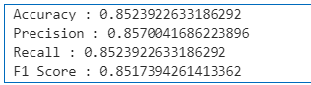

Figure 54. Performance metrices of GRU

The reported performance metrics, including an accuracy of 85.24%, precision of 85.70%, recall of 85.24%, and an F1 score of 85.17%, suggest that the Gated Recurrent Unit (GRU) model is proficient in human activity recognition. The high accuracy indicates the model's overall effectiveness in correctly classifying activities, while precision reflects its ability to make accurate positive predictions. The balanced values of recall and F1 score signify that the model not only identifies a substantial portion of relevant instances but also strikes a good balance between precision and recall. The GRU's success in this context can be attributed to its capacity to capture temporal dependencies in sequential data, essential for discerning patterns in human activities over time, thereby contributing to the model's robust performance in activity recognition tasks.

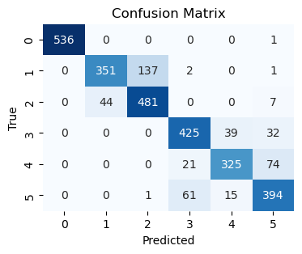

Figure 55. Confusion matrix of GRU

The confusion matrix shows that the GRU model performs well on most activities, with accuracy values above 90% for all classes. However, the model struggles to distinguish between Walking and Running, with a precision score of 85% for Walking and a recall score of 90% for Running. This means that the model is likely to misclassify some Walking cases as Running and some Running cases as Walking. There are a few possible reasons why the model may struggle to distinguish between Walking and Running. First, the two activities are very similar in terms of their sensor data. Second, the training data may not be large enough or diverse enough to allow the model to learn the subtle differences between Walking and Running.

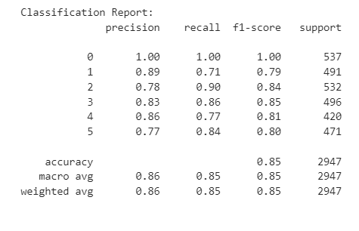

Figure 56. Classification Report of GRU

The classification report reveals the robust performance of the Gated Recurrent Unit (GRU) model in human activity recognition. With an overall accuracy of 85%, the model showcases high precision (ranging from 77% to 100%) and balanced recall values, indicating its effectiveness in accurately identifying various activities. Notably, the model excels in precision for class 0, achieving a perfect score, and maintains competitive performance across all other classes. The balanced F1-scores and macro-average metrics further underscore the GRU model's ability to achieve a harmonious trade-off between precision and recall, ensuring a reliable and accurate classification of diverse human activities.

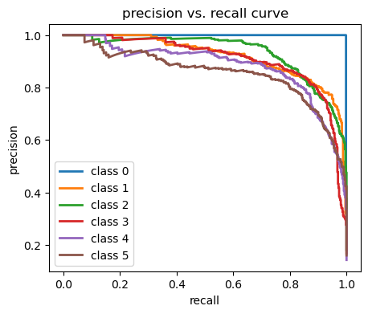

Figure 57. Precision vs recall curve of GRU

The GRU model seems to perform well on most activities, especially Sitting and Standing. However, it might be overfitting on Walking and overconfident in Upstairs predictions, leading to potential misclassifications. It also struggles to distinguish similar activities and Downstairs from Upstairs.

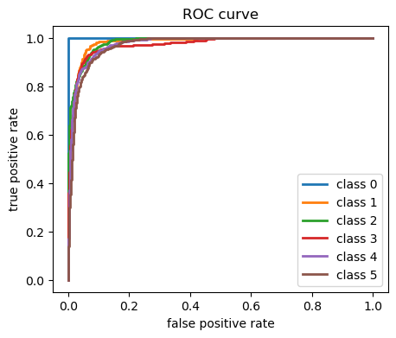

Figure 58. Roc curve of GRU

The ROC curve is a powerful tool to visualize and evaluate the performance of a binary classifier. In this case, the classifier is trying to distinguish between one specific activity (Walking Upstairs) and everything else (Non-Walking Upstairs).The ideal ROC curve would be a diagonal line going from the bottom left corner (FPR=0, TPR=0) to the top right corner (FPR=1, TPR=1). This means the model perfectly distinguishes Walking Upstairs from everything else: it never misses a true positive (TPR=1) and never makes a false positive (FPR=0).the ROC curve tells a positive story about the GRU model's performance in recognizing Walking Upstairs. While there's room for improvement, the model already shows good sensitivity and a knack for catching this specific activity without getting overwhelmed by false alarms. With some refinements, the model can become even more accurate and reliable for HAR tasks.

**parameters used in GRU**

|  |  |  |
| --- | --- | --- |
| **S. No** | **Parameter Name** | **Value** |
| 1 | Learning Rate | 0.001 |
| 2 | No of units | 64 |
| 3 | Batch Size | 32 |
| 4 | Activation function | Relu |
| 5 | Optimizer | Adam |
| 6 | Loss function | Sparse_Categorical_crossentropy |
| 7 | Input shape | (561,1) |
| 8 | Weight Initialization | Xavier Initialization |

**Inference**

The classification report reveals the robust performance of the Gated Recurrent Unit (GRU) model in human activity recognition. With an overall accuracy of 85%, the model showcases high precision (ranging from 77% to 100%) and balanced recall values, indicating its effectiveness in accurately identifying various activities. Notably, the model excels in precision for class 0, achieving a perfect score, and maintains competitive performance across all other classes. The balanced F1-scores and macro-average metrics further underscore the GRU model's ability to achieve a harmonious trade-off between precision and recall, ensuring a reliable and accurate classification of diverse human activities.

**6.4 Comparisons Table:**

|  |  |  |  |  |  |
| --- | --- | --- | --- | --- | --- |
| **S. No** | **Algorithm name** | **Accuracy** | **Precision** | **Recall** | **F1 Score** |
| 1 | LSTM | 80.89 | 0.8233 | 0.8089 | 0.8087 |
| 2 | MLP | 93.04 | 0.9341 | 0.9304 | 0.93 |
| 3 | GRU | 85.23 | 0.857 | 0.8523 | 0.8517 |